Transformational Grammar

🔹 What is Transformational Grammar
# Source: Chatgpt (GPT-4-turbo) at [8/3/2025]
(Also called Transformational-Generative Grammar)
Transformational grammar is a theory of grammar developed by Noam Chomsky that explains how humans generate and understand infinite sentences from a finite set of rules.
It uses transformations (rule-based operations) to convert deep structures (core meanings) into surface structures (actual sentences we speak or write).

✅ Key Features of Transformational Grammar:
# Source: Chatgpt (GPT-4-turbo) at [8/3/2025]
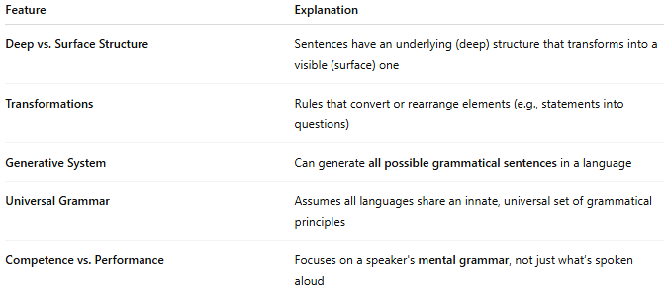
Feature | Explanation
Deep vs. Surface Structure | Sentences have an underlying (deep) structure that transforms into a visible (surface) one
Transformations | Rules that convert or rearrange elements (e.g., statements into questions)
Generative System | Can generate all possible grammatical sentences in a language
Universal Grammar | Assumes all languages share an innate, universal set of grammatical principles
Competence vs. Performance | Focuses on a speaker's mental grammar, not just what’s spoken aloud

✅ Deep Structure vs. Surface Structure:
# Source: Chatgpt (GPT-4-turbo) at [8/3/2025]
Sentence: "Is the dog barking?"
- Deep structure: The dog is barking.
- Transformation: Apply question formation rule
- Surface structure: Is the dog barking?

✅ Examples of Transformational Rules:
# Source: Chatgpt (GPT-4-turbo) at [8/3/2025]
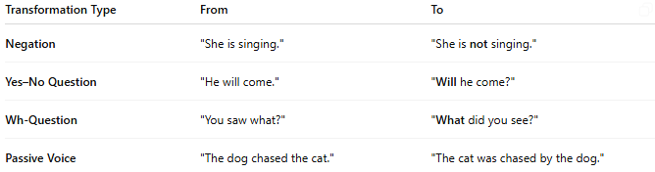
Transformation Type | From | To
Negation | "She is singing." | "She is not singing."
Yes–No Question | "He will come." | "Will he come?"
Wh-Question | "You saw what?" | "What did you see?"
Passive Voice | "The dog chased the cat." | "The cat was chased by the dog."

✅ Important Concepts in Transformational Grammar:
# Source: Chatgpt (GPT-4-turbo) at [8/3/2025]
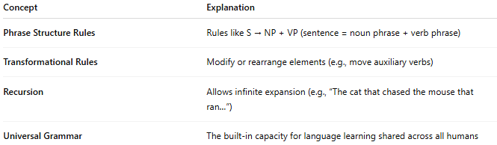
Concept | Explanation
Phrase Structure Rules | Rules like S → NP + VP (sentence = noun phrase + verb phrase)
Transformational Rules | Modify or rearrange elements (e.g., move auxiliary verbs)
Recursion | Allows infinite expansion (e.g., “The cat that chased the mouse that ran…”)
Universal Grammar | The built-in capacity for language learning shared across all humans

✅ Transformational Grammar vs. Other Types:
# Source: Chatgpt (GPT-4-turbo) at [8/3/2025]
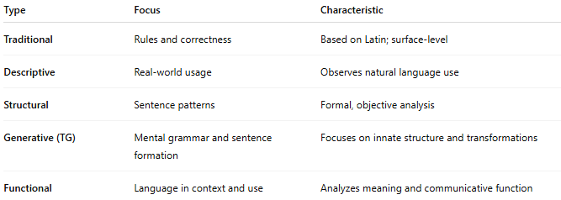
Type | Focus | Characteristic
Traditional | Rules and correctness | Based on Latin; surface-level
Descriptive | Real-world usage | Observes natural language use
Structural | Sentence patterns | Formal, objective analysis
Generative (TG) | Mental grammar and sentence formation | Focuses on innate structure and transformations
Functional | Language in context and use | Analyzes meaning and communicative function

✅ Why Transformational Grammar Matters:
# Source: Chatgpt (GPT-4-turbo) at [8/3/2025]
- Explains how people produce and understand novel sentences
- Supports theories of language acquisition and cognitive psychology
- Forms the basis for modern syntax and computational linguistics
- Helps distinguish between form (structure) and function (meaning)

📝 Summary:
# Source: Chatgpt (GPT-4-turbo) at [8/3/2025]
- Transformational grammar is a rule-based theory of syntax developed by Noam Chomsky.
- Explains how deep structures become surface sentences through transformations.
- Focuses on mental grammar, recursion, and universal principles of language.
- Influential in linguistics, AI, and cognitive science.

